
Reading at Highfield

We all know that reading is an essential skill and that there are many ways that it enriches our lives. It is the love of reading and the appreciation of all its uses and benefits that we want to encourage in our children, and we welcome your support in the achievement of this aim. We hope the following notes will help to make the time you spend reading with the children both rewarding and pleasurable.

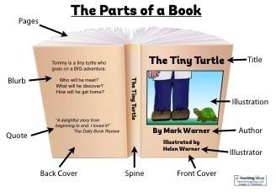
BEFORE YOU START
  - Sit comfortably alongside the child
  - Let the pupil be ‘in charge’ of the book i.e. turning the pages, but make sure the book is shared so that you can clearly see what is being read.
  - Before starting to read make sure you know each other’s names and are relaxed with one another.

DISCUSSION ABOUT BOOK
  - Discuss the story so far (characters, plot)
  - New book? Read the ‘blurb’
  - Allow child to familiarise themselves with the different parts of the book

READING: HELPING A CHILD TO MAINTAIN MOMENTUM AND SELF-CORRECT
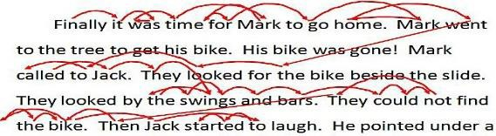
A fundamental part of reading is the ability to perceive words in ‘thought phrases’ therefore if you run a pen or finger along the line being read keep it moving and make sure it does not impede natural eye movements ahead and behind the word being spoken aloud. If an error is made, pause pencil or finger but without necessarily saying anything to give opportunity to self-correct.

Guiding a child (ruler or pen) can be useful for:
- self-correction if pen is paused
- maintaining appropriate speed (could indicate if book too hard)
- pointing to illustration as contextual clue for self-help

Guiding is not necessary when children are fluent but book should still be physically shared with adult

READING: IF A CHILD IS STUCK
If a child is stuck try one or more of the following strategies:
- encourage pupil to build the word up using individual phonic sounds or letter blends
- supply the word, if appropriate restart the sentence so that that unknown word is read by the child
- supply the word, continue until appropriate stopping point then return to unknown word and discuss it together
- use pictures as contextual clues
- make note of unknown word for class teacher

CHECKING COMPREHENSION (DURING READING)
Some suggestions of questions you could ask:
- What do you think will happen next?
- Can you predict how the story will end?
- What would you have done if you were the character?
- How would you have felt if you were the character?
- As you read, what are you wondering about?
- Can you put what you’ve just read in your own words?

ENDING
  - Stop at an appropriate point e.g. end of page/chapter
  - Discuss what you have read together
  - Make some positive remarks about the time you have spent together
  - Make an entry in the child’s reading record
  - If a child needs to choose a new book, please refer them to their teacher or classroom assistant

We want the experience of shared reading to be an opportunity for the pupil to have the individual attention of an adult, other than their class teacher, through which their enjoyment and skill in reading is enhanced.
We appreciate your help and trust that you will enjoy being part of Highfield South Farnham pupils’ reading programme.

