
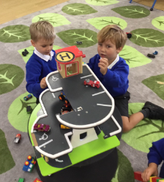

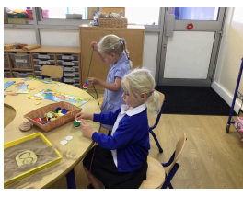


Parents’ Guide

2024-2025

Introduction

All children attending Highfield South Farnham School in Reception and Nursery have a personal, online Learning Journey which records photos, observations and comments in line with the Early Years Foundation Stage Framework. This enables us to build a record of each child’s learning and achievements during their years at Highfield South Farnham.
We use the Tapestry system which is hosted on secure, dedicated servers based in the UK. You will have password protected access to your child’s online Learning Journey and we encourage you to contribute to it by uploading photos, videos and comments of your own based on your child’s learning development and experiences at home. You are also able to comment on observations made by South Farnham staff, to support the observations made in school.
If you do not have access to the internet at home or work, we are able to download your child’s Learning Journey as a pdf file that can be printed.
We are delighted that you have completed and returned the permission form to let us know you would like to use the online system.

Where do I start?

Your child’s Learning Journal is currently being linked to your parent account. You will be emailed, using the email addresses provided, with a link to the Tapestry log on page, your username (which is your email address) and you will be able to set your password. Please check your ‘junk folder’ for your registration email.
The Tapestry app is free of charge and available from the App Store. Specific user guides are available and can be found on the tapestry website.
As a parent/carer you can choose who also has access to your child’s learning journey at any time. If you wish to give additional access to members of the family, please let us know and they will be emailed an activation link.

Changing my settings in Tapestry

On the computer: At the top right of your screen you will see your name, selecting this will give you the option to ‘Edit Preferences’. Choose this option and you will be presented with a screen giving you the option to change your email address and password.
You also have the option to request an email to be sent to you whenever a new observation is added to your child’s Learning Journey – just tick the relevant box if you would like to add this function. Please note that you will only receive notifications when new observations are added, not when replies to comments from parent or staff members are posted.
On iPhone/iPad: To change your settings on the iPhone/iPad app, click the ‘cog’ button on the bottom right hand side of the application. This enables you to change the password and/or email address.
Viewing my child’s Learning Journey
You will see your child’s observations on your ‘Observations’ tab (home screen) – selecting any one of these will open up the observation for you to look at. You may add comments in the box at the bottom of the observation, if you would like to. You can display all entries or entries for particular timeframes or media types by using the drop-down tabs on your ‘Observations’ screen.
Adding an entry to my child’s Learning Journey
Choose the ‘Add Observation’ option (or the ‘plus’ icon on your iPhone/iPad) and add the relevant information into the boxes on the screen. Photos and videos may be uploaded by choosing the ‘add media’ option. When you have saved your observation, you may go back to the home screen at any time by choosing the ‘Observations’ tab or clicking on the Tapestry logo (on the cloud, top left corner).
If you have any problems please email: info.highefield@sfet.org or speak to your class teacher.
Please note: The online learning journey is used to record your child’s learning and achievements. It is not to be used as a general communication tool between School and home and is not monitored on a daily basis for this purpose. If the school feels a comment or observation is not relevant, it may not appear as part of your child’s Learning Journal. If you wish to communicate with your child’s teacher, please speak to them directly at drop off or pick up time.

